Lab - Troubleshoot Device Access and File Transfer

# Topology

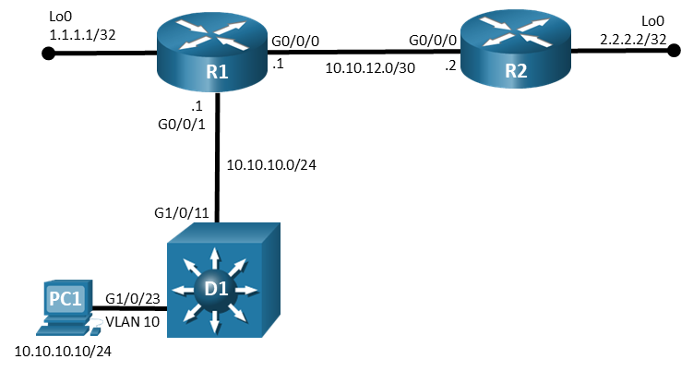

# Addressing Table

| Device | Interface | IP Address | Subnet Mask |
| --- | --- | --- | --- |
| R1 | G0/0/0 | 10.10.12.1 | 255.255.255.0 |
| R1 | G0/0/1 | 10.10.10.1 | 255.255.255.0 |
| R2 | G0/0/0 | 10.10.12.2 | 255.255.255.0 |
| D1 | VLAN 10 | 10.10.10.2 | 255.255.255.0 |
| PC1 | NIC | 10.10.10.10 | 255.255.255.0 |

# Objectives

Troubleshoot device access and file transfer issues in the configurations.

# Background / Scenario

In this topology, routers R1, R2, and switch D1 are configured with access and file transfer capabilities. You will be loading configurations with intentional errors onto the network. Your tasks are to FIND the error(s), document your findings and the command(s) or method(s) used to fix them, FIX the issue(s) presented here, and then test the network to ensure both of the following conditions are met:

* + - * 1. the complaint received in the ticket is resolved
        2. full functionality is restored

**Note**: The routers used with CCNP hands-on labs are Cisco 4221 with Cisco IOS XE Release 16.9.4 (universalk9 image). The switches used in the labs are Cisco Catalyst 3650 with Cisco IOS XE Release 16.9.4 (universalk9 image). Other routers, switches, and Cisco IOS versions can be used. Depending on the model and Cisco IOS version, the commands available and the output produced might vary from what is shown in the labs. Refer to the Router Interface Summary Table at the end of the lab for the correct interface identifiers.

**Note**: Make sure that the switches have been erased and have no startup configurations. If you are unsure, contact your instructor.

# Required Resources

* 2 Routers (Cisco 4221 with Cisco IOS XE Release 16.9.4 universal image or comparable)
* 1 Switch (Cisco 3560 with Cisco IOS XE Release 16.9.4 universal image or comparable)
* 1 PC (Choice of operating system with terminal emulation program installed)
* Console cables to configure the Cisco IOS devices via the console ports
* Ethernet cables as shown in the topology

# Instructions

## Trouble Ticket 23.1.2.1

Scenario:

There have been reports received regarding the ability to copy configuration files from some of the devices to the TFTP server running on PC1.

Use the commands listed below to load the configuration files for this trouble ticket:

|  |  |
| --- | --- |
| Device | Command |
| R1 | **copy flash:/enarsi/23.1.2.1-r1-config.txt run** |
| R2 | **copy flash:/enarsi/23.1.2.1-r2-config.txt run** |
| D1 | **copy flash:/enarsi/23.1.2.1-d1-config.txt run** |

* PC1 should be manually configured and able to ping its default gateway, as shown in the Addressing Table.
* PC1 needs to have the TFTP Server software running, make certain TFTP is configured to send and receive files.
* Passwords on all devices are **cisco12345**. If a username is required, use **admin**.

Configuration files are to be copied from each of the devices to the TFTP server using the following commands:

R1# **copy running-config tftp://10.10.10.10/r1-config.txt**

R2# **copy running-config tftp://10.10.10.10/r2-config.txt**

D1# **copy running-config tftp://10.10.10.10/d1-config.txt**

* After you have fixed the ticket, change the MOTD on EACH DEVICE using the following command:

**banner motd # This is $(hostname) FIXED from ticket <ticket number> #**

* Save the configuration by issuing the **wri** command (on each device).
* Inform your instructor that you are ready for the next ticket.
* After the instructor approves your solution for this ticket, issue the **reset.now** privileged EXEC command on each device. This script will clear your configurations and reload the devices.

## Trouble Ticket 23.1.2.2

Scenario:

A network technician is attempting to copy the current configuration from router R1 to R2 flash using the command:

R1# **copy running-config scp://admin@10.10.12.2/enarsi/r1-config.txt**

The command fails, however, SSH appears to be working correctly.

Use the commands listed below to load the configuration files for this trouble ticket:

|  |  |
| --- | --- |
| Device | Command |
| R1 | **copy flash:/enarsi/23.1.2.2-r1-config.txt run** |
| R2 | **copy flash:/enarsi/23.1.2.2-r2-config.txt run** |
| D1 | **copy flash:/enarsi/23.1.2.2-d1-config.txt run** |

* PC1 should be manually configured and able to ping its default gateway, as shown in the Addressing Table.
* Passwords on all devices are **cisco12345**. If a username is required, use **admin**.
* After you have fixed the ticket, change the MOTD on EACH DEVICE using the following command:

**banner motd # This is $(hostname) FIXED from ticket <ticket number> #**

* Then save the configuration by issuing the **wri** command (on each device).
* Inform your instructor that you are ready for the next ticket.
* After the instructor approves your solution for this ticket, issue the **reset.now** privileged EXEC command**.** This script will clear your configurations and reload the devices.

## Trouble Ticket 23.1.2.3

Scenario:

All devices are to be accessible from the management PC using SSH. It has been reported that some devices are not permitting access.

Use the commands listed below to load the configuration files for this trouble ticket:

|  |  |
| --- | --- |
| Device | Command |
| R1 | **copy flash:/enarsi/23.1.2.3-r1-config.txt run** |
| R2 | **copy flash:/enarsi/23.1.2.3-r2-config.txt run** |
| D1 | **copy flash:/enarsi/23.1.2.3-d1-config.txt run** |

* PC1 should be manually configured and able to ping its default gateway, as shown in the Addressing Table.
* Passwords on all devices are **cisco12345**. If a username is required, use **admin**.
* After you have fixed the ticket, change the MOTD on EACH DEVICE using the following command:

**banner motd # This is $(hostname) FIXED from ticket <ticket number> #**

* Then save the configuration by issuing the **wri** command (on each device).
* Inform your instructor that you are ready for the next ticket.
* After the instructor approves your solution for this ticket, issue the **reset.now** privileged EXEC command**.** This script will clear your configurations and reload the devices.

# Router Interface Summary Table

| Router Model | Ethernet Interface #1 | Ethernet Interface #2 | Serial Interface #1 | Serial Interface #2 |
| --- | --- | --- | --- | --- |
| 1800 | Fast Ethernet 0/0 (F0/0) | Fast Ethernet 0/1 (F0/1) | Serial 0/0/0 (S0/0/0) | Serial 0/0/1 (S0/0/1) |
| 1900 | Gigabit Ethernet 0/0 (G0/0) | Gigabit Ethernet 0/1 (G0/1) | Serial 0/0/0 (S0/0/0) | Serial 0/0/1 (S0/0/1) |
| 2801 | Fast Ethernet 0/0 (F0/0) | Fast Ethernet 0/1 (F0/1) | Serial 0/1/0 (S0/1/0) | Serial 0/1/1 (S0/1/1) |
| 2811 | Fast Ethernet 0/0 (F0/0) | Fast Ethernet 0/1 (F0/1) | Serial 0/0/0 (S0/0/0) | Serial 0/0/1 (S0/0/1) |
| 2900 | Gigabit Ethernet 0/0 (G0/0) | Gigabit Ethernet 0/1 (G0/1) | Serial 0/0/0 (S0/0/0) | Serial 0/0/1 (S0/0/1) |
| 4221 | Gigabit Ethernet 0/0/0 (G0/0/0) | Gigabit Ethernet 0/0/1 (G0/0/1) | Serial 0/1/0 (S0/1/0) | Serial 0/1/1 (S0/1/1) |
| 4300 | Gigabit Ethernet 0/0/0 (G0/0/0) | Gigabit Ethernet 0/0/1 (G0/0/1) | Serial 0/1/0 (S0/1/0) | Serial 0/1/1 (S0/1/1) |

**Note**: To find out how the router is configured, look at the interfaces to identify the type of router and how many interfaces the router has. There is no way to effectively list all the combinations of configurations for each router class. This table includes identifiers for the possible combinations of Ethernet and Serial interfaces in the device. The table does not include any other type of interface, even though a specific router may contain one. An example of this might be an ISDN BRI interface. The string in parenthesis is the legal abbreviation that can be used in Cisco IOS commands to represent the interface.

End of document